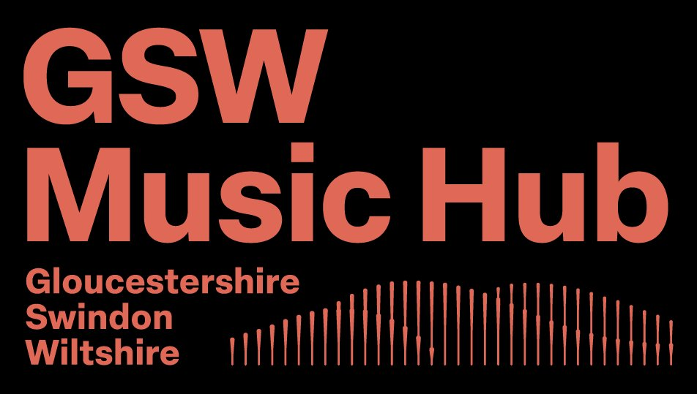
Funding Bulletin for Wiltshire Schools
Term 5 | 13 April – 22 May 2026

Open funds this term
These funders have deadlines falling during or shortly after Term 5. Act now to avoid missing out.
Funder | Amount | Deadline | Key details
UMUKSF School Award | Up to £800 | 17 June 2026 | Apply online at https://www.umuksoundfoundation.com/  by 10am. Schools teaching the national curriculum. Instruments and equipment.
UMUKSF Teacher Award | Up to £800 | 17 Jun 2026 | For one-off music teacher CPD/training courses. Apply online by 10am. See their website for details https://www.umuksoundfoundation.com/
Music For All | Numbers of instruments as outlined in guidelines | 07 May 2026 | Funding for various instruments. Apply online, https://www.musicforall.org.uk/schools-and-community-groups-awards/ by 12pm.

Looking for more funding opportunities?
A comprehensive Funding for Music in Schools guide is available covering all eligible funders (including rolling/no-deadline funders like Awards for All, Garfield Weston, and ACE Project Grants), partnership routes, and practical application tips. Visit the GSW Music Hub fundraising page at https://gswmusichub.org.uk/fundraising-support/.

Funder spotlight: UMUKSF
The Universal Music UK Sound Foundation is one of the quickest, simplest grants a school can apply for. Here’s what you need to know:
- Who can apply? Any school teaching the national curriculum in the UK or Ireland.
- What does it fund? Musical instruments and equipment (School Award) or one-off CPD/training courses for music teachers (Teacher Award). Up to £800 each.
- What won’t it fund? Tuition fees, peripatetic lesson costs, or staffing.
- How to apply: Go to umuksoundfoundation.com and click ‘School Application’. Read their Application Instructions document first – it lists everything you’ll need. The online form cannot be saved partway through, so have all your information ready before you start. It closes automatically at 10am on the deadline.
- Top tip: Show how the instruments or training will benefit the whole school, not just exam students. Previous successful applications have emphasised inclusive, whole-school access to music-making.
- Reapplication: If you’ve received a UMUKSF grant before, you must wait two years before reapplying. If your school has never applied, you have an excellent chance.

Did you know? The charity partner route
Several major music funders – including Youth Music (grants from £2,000 to £300,000) and BRIT Trust (up to £30,000) – don’t accept applications from schools directly. But a registered charity or constituted organisation can apply for a project that is delivered in your school, with your school as a named partner.
This is a well-established route and could unlock significantly larger funding than most school-eligible grants. If you have an idea for a music project and would like to explore whether a charity partner could help you access these funds, get in touch.

Free funding advice for Wiltshire schools
The GSW Music Hub offers free one-to-one funding advice sessions. Whether you’re applying for the first time or want to discuss larger partnership opportunities, I can help you find the right funders and strengthen your application. Drop me an email to book a session.
Deborah Potts, Funding Adviser – GSW Music Hub
deborah@dpconsulting.co.uk

This bulletin covers all 14 Wiltshire music clusters and approximately 236 schools. Your cluster coordinator can also help you access this information.
Coordinators: Emily Askew, Steph Farr, Julia Falaki, Emily Malcolm, Louise Jordan, Lauren Lane
Full guide: A comprehensive Funding for Music in Schools guide covering all eligible funders, partnership routes, and practical tips is available from the GSW Music Hub.

